Table S2 All characteristics of all studies on the use of non-coding RNAs as diagnostic biomarkers of breast cancer.
Author | Year | Ethnicity | RNA name | regulation | origin | Tumor size | Control size | Method | Endogenous reference | Specimen type | Specimen source | Nontumorous sample selection | SEN | SPE | AUC | Cutoff | P value
Arabkari V1 | 2019 | European | miR-145 miR-486  miR-195 | up  down | Galway University Hospital (GUH), Ireland | 38 | 20 | absolute RT-qPCR | synthetic miRNA oligo | blood | luminal A breast cancer patients | healthy females | 0.76 | 0.81 | 0.875 | - | P<0.05
Arabkari V2 | 2019 | European | miR-155 miR-486  miR-195 | up  down | Galway University Hospital (GUH), Ireland | 38 | 20 | qPCR | miR-16 | blood | luminal A breast cancer patients | healthy females | 0.65 | 0.69 | 0.657 | - | P<0.05
Cuk K | 201304 | - | miR-148b,  miR-409-3p  miR-801 | up | - | 127 | 80 | qPCR | RNU6B | plasma | female sporadic breast cancer patients | healthy female volunteers | 0.70 | 0.55 | 0.69 | - | miR-148b (P<0.001),  miR-409-3p (P<0.0001)  miR-801 (P<0.001)
Cuk K | 201310 | - | miR-127-3p, miR-148b, miR-376a, miR-376c, miR-409-3p, miR-652 miR-801 | up | - | 150 | 80 | qPCR | cel-miR-39 | plasma | benign and malignant breast tumors | healthy women | 0.80 | 0.72 | 0.81 |  | miR-127-3p (P=0.0003), miR-148b(P<0.0001), miR-376a (P =0.03), miR-376c (P=0.03), miR-409-3p (P=0.005), miR-652 (P<0.0001) and miR-801 (P<0.0001)
Eichelser C1 | 2013 | European | miR-34a | up | Hamburg region and Rhein-Neckar-Karlsruhe region, Germany | 120 | 40 | qPCR | miR-16 | serum | patients with primary breast cancer after surgery and before chemotherapy (M0) | healthy women | 0.598  0.449  0.766 | 0.76  1  1 | 0.636  0.699  0.879 | - | P=0.013  P=0.001  P=0.0001
Eichelser C2 | 2013 | European | miR-93
Eichelser C3 | 2013 | European | miR-373
Fang R | 2019 | Asian | hsa-miR-324-3p/hsa-miR-382-5p,  hsa-miR-21-3p/hsa-miR-324-3p,  hsa-miR-30a-5p/has-miR-30e-5p,  hsa-miR-221-3p/has-miR-324-3p | miRNA ratios  up  down  -  down | Rush Breast Cancer Repository, Shanghai, China | 53 | 38 | qPCR | miR-16 | plasma | early stage breast cancer | normal patients | 0.89 | 0.925 | 0.901 | - | P<0.0001
Heydari N | 2018 | Asian | miRNA-140-3p | Up | University of Medical Sciences, Babol, Iran | 40 | 40 | qPCR | miR-16 | serum | breast cancer patients | Healthy controls | 0.70 | 0.50 | 0.667 | 0.13 | P=0.01
Kassem NM1 | 2019 | African | miR-34a | up | Kasr Al-Ainy Center of Clinical Oncology and nuclear medicine, School of Medicine, Cairo University, Egypt | 39 | 10 | qPCR | miR-39 | plasma | Newly diagnosed locally advanced BC female patients | healthy volunteers | 0.974 | 1 | 0.995 | 2.57 | miR-34a P<0.001
Kassem NM2 | 2019 | African | miR-125b |  |  |  |  |  |  |  |  |  | 0.667 | 0.70 | 0.68 | 8.69 | miR-125b P=0.2.
Kodahl AR | 2014 | European | miR-15a, miR-18a, miR-107, miR-133a, miR-139-5p, miR-143, miR-145, miR-365, miR-425 | - | the Department of Oncology, Odense University Hospital, Denmark | 60 | 51 | qPCR | - | serum | early-stage breast cancer patients | healthy controls | 0.833 | 0.412 | 0.665 | - | P=0.012
Li M1 | 2018 | Asian | miR-106a-5p miR-20b-5p | up | the First Affiliated Hospital of Nanjing Medical University, China | 30 | 30 | qPCR | cel-miR-39  miR-16 | plasma | histopathologically confirmed BC | healthy controls | 0.82 | 0.83 | 0.857 | 0.47
Li M2 | 2018 | Asian | miR-106a-5p miR-20b-5p |  |  |  |  |  |  | serum | histopathologically confirmed BC | healthy controls | 0.94 | 0.88 | 0.959 | 0.48
Liu W | 2018 | Asian | miR-940 | down | Shanxian Central Hospital, china | 128 | 70 | qPCR | U6 | serum | breast cancer patients | Healthy controls | 0.945 | 0.786 | 0.905 |  | P<0.001
Lu M | 2016 | Asian | miR-127-3p | UP | Affiliated Hospital of Nantong University, Jiangsu, China | 102 | 177 | qPCR | U6 | plasma | breast cancer patients | non-cancerous patients (benign and control groups). | 0.782 | 0.646 | 0.767 | 3.471 | P<0.001
Lyng MB | 2016 | - | miR-15a, miR-18a, miR-107, miR-133a, miR-139-5p, miR-143, miR-145, miR-365, miR-425 | --- | -- | 36 | 80 | qPCR | miRNA-451 miRNA-23a | serum | invasive breast cancer  cases | no mammographydetected breast cancer was selected for the control group | 0.73 | 0.44 | 0.61 | 0.56 | P<0.0001
Madhavan D | 2012 | - | miR-141  miR-200b,  miR-200c  miR-210  miR-768-3p | UP | - | 61 | 76 | qPCR | cel-miR-39. | plasma | circulating tumor cells (CTCs)-positive metastatic breast cancer  (MBC) cases | Healthy controls | 0.9 | 0.9 | 0.95 | - | P<0.00001
McDermott AM | 2014 | - | miR-29a, miR-181a, miR-652 | down | - | 54 | 56 | qPCR | miR-16 | blood | Luminal A-like breast cancer | controls | 0.77 | 0.74 | 0.80 | 0.80 | -
Mishra S1 | 2015 | Asian | miR-195-5p | down | King George Medical University, Lucknow, India | 45 | 45 | qPCR | U6 snRNA hsa-miR-16 | plasma | BC patients with different stages and molecular subtypes | healthy controls | 0.778 | 1 | 0.901 | - | P<0.0001
Mishra S2 | 2015 | Asian | miR-495 |  |  |  |  |  |  |  |  |  | 1 | 0.667 | 0.901 | - | P<0.0001
Sun Y | 2012 | Asian | miR-155 | up | Cancer Hospital, Chinese Academy of Medical Sciences | 103 | 55 | qPCR | miR-155 and cel-miR-39. | serum | breast cancer patients | healthy subjects | 0.65 | 0.818 | 0.801 | 1.911 | P<0.001
Swellam M1 | 2018 | - | miR-21 | Up | -- | 137 | 98 | qPCR | RNU6-2 | blood | Primary breast cancer patients | non-cancerous patients (benign and control groups). | 0.708  0.978  0.934 | 0.918  0.755  0.99 | 0.861  0.833  0.987 | 228  6.44  360 | P<0.0001
Swellam M2 | 2018 | - | miR-222
Swellam M3 | 2018 | - | miR-373
Yin WB | 2017 | Asian | hsa_circ_0001785 | Up | First People's Hospital of Shangqiu, Henan, China | 57 | 17 | qPCR | GAPDH | plasma | cases of breast cancer patients | Healthy controls | 0.764 | 0.699 | 0.784 | 0.981 | P<0.01
Zaleski M | 2018 | European | miR-34a | up | The University Hospital Bonn, Germany | 55 | 28 | qPCR | miR-16 | serum | breast cancer | Healthy women | 0.95 | 0.34 | 0.722 | - | -
Zhang K | 2016 | Asian | lncRNA H19 | up | Affiliated Hospital of Southwest Medical University, Sichuan, China | 30 | 30 | qPCR | β-actin | plasma | early stage BC patients | healthy controls | 0.567 | 0.867 | 0.81 | - | P<0.0001
Zhang L | 2015 | Asian | miR-199a,  miR-29c,  miR-424 | up | Beijing Cancer Hospital, China | 101 | 72 | qPCR | miR-16  miR-191/484 | serum | breast cancer patients | healthy controls | 0.772 | 0.889 | 0.905 | 3.448 | P<0.0001
Zhang Y | 2016 | Asian | lncRNA HOTAIR | up | the Affiliated Hospital of Southwest Medical University, Luzhou, China | 88 | 100 | qPCR | β-actin. | plasma | breast cancer patients | healthy controls | 0.692 | 0.933 | 0.8 | - | P<0.0001
Zhao L1 | 2018 | Asian | miR-20a | up | Xiangya Hospital, Hunan, China | 36 | 32 | qPCR | U6snRNA  GAPDH | blood | breast cancer patients | healthy control | 0.833 | 0.875 | 0.87 | 8.21 | P<0.001
Zhao L2 | 2018 | Asian | lncRNA XIST | down |  |  |  |  |  |  |  |  | 0.778 | 0.656 | 0.78 | 13.10 | P<0.001

Table S3 Meta-regression analyses with sample source of blood.
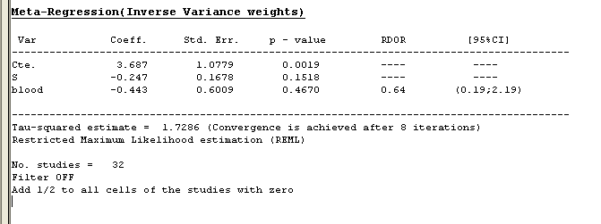
Table S4 Meta-regression analyses with sample source of plasma.
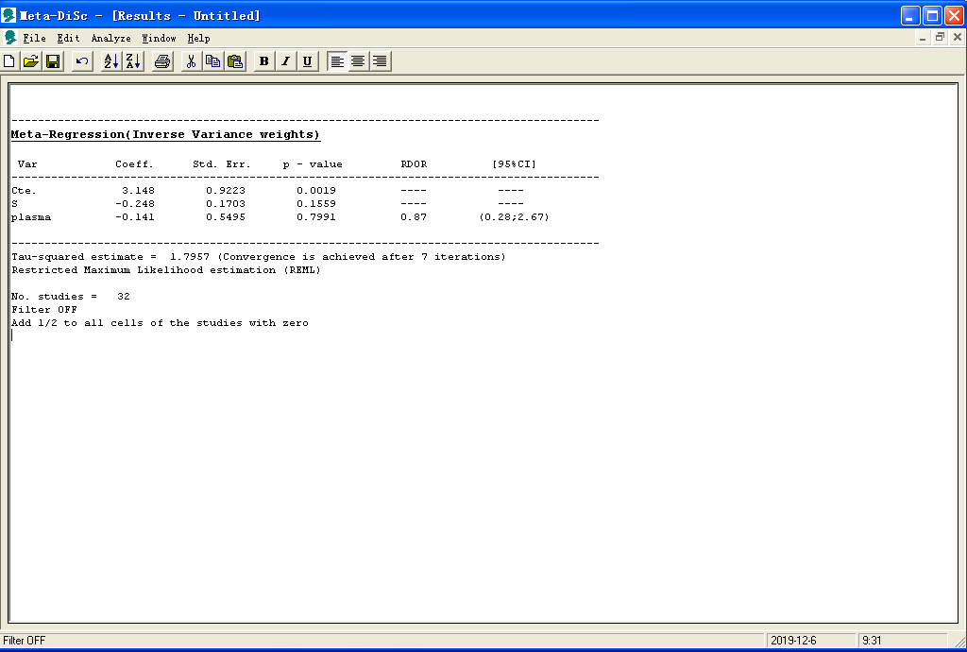
Table S5 Meta-regression analyses with sample source of serum.
